WCOC Sale Fell Cumbrian Galoppen - Sunday 27th June 2021
This event will be run under British Orienteering guidelines for Covid secure events. All participants must familiarise themselves with the British Orienteering Participant Code of Conduct. (Link below). They must NOT attend if they or any member of their household has Covid symptoms. Maintain social distance at all times from fellow competitors and event officials, use the hand sanitising stations provided and do not linger to socialise.
BO Participant Code of Conduct

TRAVEL DIRECTIONS
The event will be signed from the A66 at NY 17507 30375 sign posted Wythop Mill. From the turning off the A66 follow the signs taking you into the small village of Wythop Mill. At the cross roads continue straight ahead and after 600m bear right over the small bridge. Turn left at the junction at the top of the hill, and follow the road past Old Scales Farm. Parking will be found past the farm on the right.
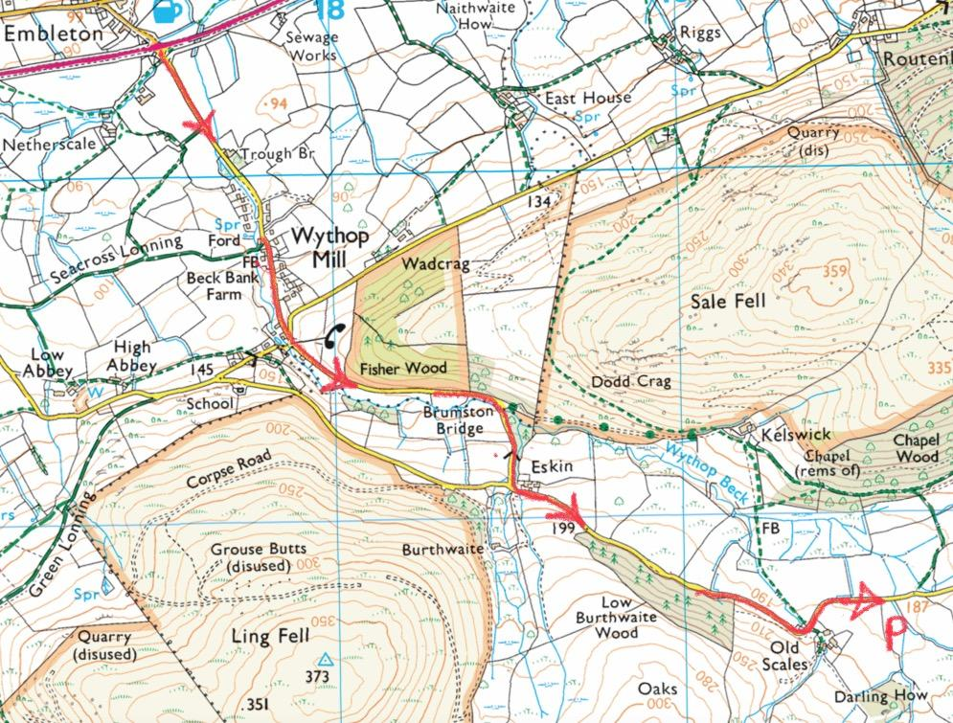

PARKING
£2 PER VEHICLE – Please bring correct amount as no change will be given.
Parking will be in the same field as Assembly. It is located in the second field on the right as you pass Old Scales Farm (CA13 9YR) in the Wythop Valley. Entrance to the field is through a farm gate at NY 19583 28742
Please be aware of competitors on the road as they make their way to the start.

FACILITIES AT ASSEMBLY
Assembly is located in the same field as the car parking. There will no Entry on the Day. There will be two toilets in the assembly field. Enquiries, Yellow map collection and download will be available at registration. No results splits will be provided on the day. No key drop available. A First Aid bag will be available. Please try and self-administer First Aid where possible.

REGISTRATION
Registration: 10:00 to 11:30
Starts: 10:30 to 12:30
Courses close: 14:30

STARTS/FINISH
There are two starts. Both use the same approach which will involve walking a short section of the road – follow taped route and leave gates as you found them. Allow 20 minutes to get to the starts. All competitors must be checked off the start list when leaving the assembly field. Whistles are recommended. Cagoules will be checked here if deemed compulsory. Please sanitise your hands before and after your run.
Start 1 – 1.25 km / walk from assembly - Light Green, Blue, Brown
Start 2 – 1.5 km / walk from assembly – Yellow, Orange, Short Green, Green
Finish is unmanned and is 800m from the assembly. The return to assembly will involve a short section of the road, follow taped route and leave gates as you found them.

START SAFETY PROCEEDURE
Please try and arrive at the start in your pre entered time slot. Follow the instructions of the start officials and maintain social distancing. It is a punching start at 1 minute intervals.

TERRAIN
Sale Fell is mostly open fell with some contour detail, as well as some vegetation, marsh and rock detail. There are some linear features such as walls, fences and a path network. Runnability can vary from excellent to slower on rougher areas. There are areas of bracken and gorse so full leg cover is mandatory. The area is grazed by sheep so check afterwards for ticks.

COURSES
Please do not climb any walls or fences. Use the crossing points provided – these are marked on the map.

Colour | Length (km) | Climb (m) | Controls | Scale | Start
Brown | 8.3 | 340 | 19 | 1:10 000 | 1
Blue | 6.3 | 270 | 16 | 1:10 000 | 1
Green | 4.9 | 180 | 15 | 1:10 000 | 2
Short Green | 3.4 | 125 | 10 | 1:10 000 | 2
Light Green | 3.2 | 180 | 11 | 1:10 000 | 1
Orange | 2.5 | 75 | 9 | 1:7 500 | 2
Yellow | 1.9 | 50 | 11 | 1:7 500 | 2

Sale Fell is not particularly high, even by Lakeland standards but it can be exposed to the weather. Please come suitably equipped. Whistles are recommended and cagoules may be compulsory. If this is the case signs will be placed on the event access road. The safety bearing is South.

EVENT OFFICIALS
Organiser: Scott Ashworth WCOC scottlashworth@hotmail.com
Planner: Ian Teasdale WCOC
Controller John Slater WCOC

NEAREST A & E HOSPITAL:
West Cumberland Hospital
Homewood Road
Hensingham
Whitehaven
CA28 8JG

